
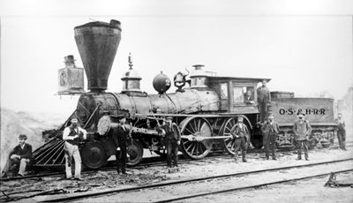
Canadian Railroad Trilogy
#14
Gordon Lightfoot

From the album ‘Complete Greatest Hits’

Rhino / Wea

Vocabulary

- bunkhouse -
- declinin’ -
- majestic -
- navvies -
- muskeg -
- strand -
- toil -
- verdant -

Do You Know It?

CAN YOU FIND ON A MAP:

- St. Lawrence
- Gaspe

Did You Catch It?

- How is the land described before the railroad is built?
- Whose perspective is it that it [railroad] was for the good of us all? (line 8)
- What would the railroad bring to a ‘young’ Canada?
- Where did these workers come from?
- What risks did they face?
- According to the songwriter, what types of terrain did they cross building the railroad?
- What other types of terrain not mentioned do you imagine they crossed?
- Find 3 metaphors from the song. Explain the comparisons.

61

Do You Get It?

- Who do you think the “naavies” are?
- Lines 22-23 say “Across the wide prairie our loved one lie sleeping Beyond the dark oceans in a place far away”. To which families is Gordon Lightfoot referring?
- What is the significance of the tempo change in the music in line 13-16?
- When the music and words slow down in line 19, why were they moving too slow?
- Who’s perspective is it that they were moving too slow?
- According to the songwriter, railroad workers earned ‘$1.00 a day and a place for my head’. Compare those wages to wages, working conditions and lifestyle of a railroad worker today.

- Did the completion of the railroad solve the battles that are talked about in line 40?
- What will be our future battles in Canada?
- Compare the mood of this song to Ribbon of Broken Dreams.

Activities and Extensions!

- Research major stops along the CPR at the time of completion (c. 1885). Plan a vacation you might take at that time. Where would you stop and why? What would you take? How much would it cost? Next, plan a trip you might take today along the same route via train. Would the places you stop to visit be the same? Would you take the same gear? What would be the current cost?

- What role did the railroad play in your community historically? Does it still have significance, historically, economically, symbolically?

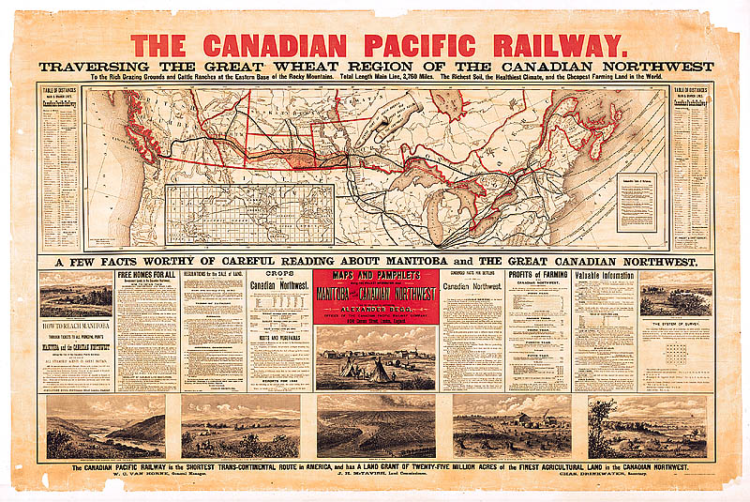

Vacation Destination!

This poster of a map produced by the Canadian Pacific Railroad company in the mid 1880’s was aimed at selling the ‘west’ to immigrants and settlers.



Teacher’s Guide

BACKGROUND INFORMATION

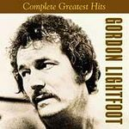

ANSWER KEY

Did You Catch It?

- Long before the Whiteman and the wheel.
- Whiteman/Europeans and Canadian government/settlers.
- Raw and manufactured goods. Wealth and prosperity to a ‘young’ and growing nation.
- Railroad workers.
- European immigrants, later Asian immigrants (ie. Chinese)
- Dangerous work, rough lifestyle, solitude and lonliness.
- Plains, muskeg, St. Lawrence lowlands.
- Answers may vary; rolling hills, mountains, plateaus, rivers, Canadian Shield (rock).
9. Answers may vary.

SUGGESTED READING

Pierre Berton, The National Dream (1969) and The Last Spike (1971); A.W. Currie, The Grand Trunk Railway of Canada (1957); W.K. Lamb, History of the Canadian Pacific Railway (1977); R.F. Legget, Railways of Canada (1973); T.D. Regehr, The Canadian Northern Railway (1976); G.R. Stevens, History of the Canadian National Railways (1973); A. Tucker, Steam Into Wilderness (1978).

ARTIST INFORMATION
Rising to prominence in the 1960’s, Gordon Lightfoot has become an icon of folk music in Canada and the rest of the world. His stirring ballads struck a chord with Canadians across the country and he has woven his music into the threads of our Canadian identity. Some of his well known works include: "Early Morning Rain," "Cotton Jenny," "Sundown," "If You Could Read My Mind," "Carefree Highway," and "The Wreck Of The Edmund Fitzgerald,"

